SecureCore for Trustworthy Commodity Computing and Communications

Award No:  0430487, 0430566  0430598 | 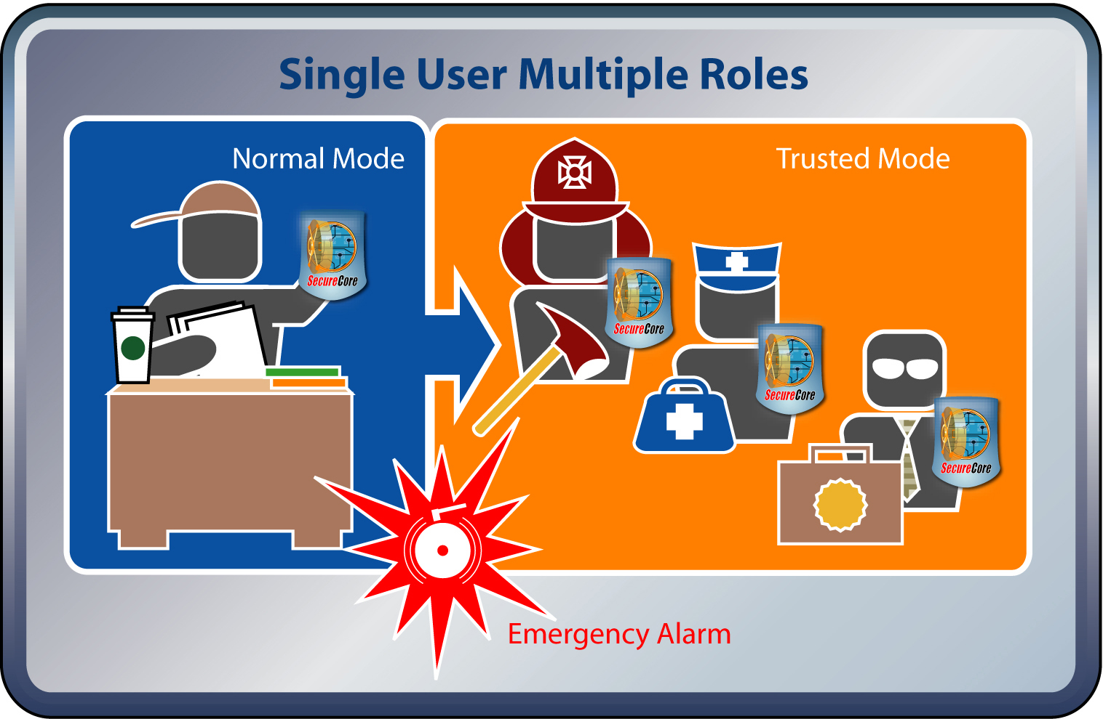
Project Title:
SecureCore for Trustworthy Commodity Computing and Communication
Investigators:
Ruby Lee
Cynthia Irvine
Terry Benzel
Institution:
Princeton University
Naval Postgraduate School
University of Southern California

Website:  http://cisr.nps.edu/projects/securecore.html  http://palms.ee.princeton.edu/securecore/ | This figure depicts a public service worker using a SecureCore-enabled PDA for normal office activities. As a result of an emergency alarm received through the device he or she is able to access critical sensitive information needed for different roles such as a fire fighter, paramedic and investigative field agent.
Project Description and Outcome -
First responders need trustworthy devices that protect their information and activities when assuming different roles. In non-crisis contexts, such devices could separate normal activities from those requiring transient trust, e.g., banking, health care and personal data management. But, during an emergency, the first responder may be need to access data owned by other government agencies or even by private parties. They may sometimes be required to temporarily access highly classified information. Such information sharing is possible when the data providers are able to control how and when their information can be used.
New software separation kernel technologies, when coupled with hardware extensions for security, can be enhanced with communications and functional support that provides an essential building block for the secure management of local and/or remote information in multiple contexts. The SecureCore project combines advanced research in hardware and software security architectures, protected communications, and mobile device security, while broadening educational opportunities in these areas.
The SecureCore architecture is based on tightly integrated and co-designed security-aware processor, secure kernel and a small set of secure network protocols. Security-aware processor (SP) architecture extensions provide mechanisms for remote trust and protect data with trust for key-management, confidentiality and integrity rooted in hardware. Its least privilege separation-kernel and trusted services software enforce mandatory access control and securely manage resources. The tight integration among hardware, software and communication, makes the architecture secure by design.
The SecureCore architecture is fundamentally different from existing systems as it enables transient trust and controlled sharing of critical information, which is absolutely required by first responders who must address emergent threats and attack scenarios. Its ease of integration with existing systems permits SecureCore technology to serve as a platform for future civilian and military mobile computing/communication devices.
Please select the Primary Strategic Outcome Goal that BEST DESCRIBES the highlight:
Foster research that will advance the frontiers of knowledge, emphasizing areas of greatest opportunity and potential and establishing the nation as a global leader in fundamental transformational science and engineering.
Secondary Strategic Outcome Goals that BEST DESCRIBES the highlight
Learning: Cultivate a world-class, broadly inclusive science and engineering workforce, and expand the scientific literacy of all citizens.
This work is notable because:

Despite rampant security vulnerabilities, most commodity computing and communication platforms meet, only performance and functionality requirements with little attention to trustworthy computing. The rapid adoption of highly-networked, pervasive mobile computing devices motivates the need to design and develop a secure integrated core for trustworthy operation of these devices.

Important recent results of the SecureCore project include:
- The security aware processor has been augmented with instructions that enable
- controlled and secure access to user's secrets
- transient, policy-controlled trust to third-party protected information, remotely
- The Security Architecture has been designed to support
- trusted path application to support transient trust usage model
- integration of SP for covert-channel free sharing of cryptographic services
- Networking and communication has been augmented with new protocols that support
- probabilistic and deterministic mobile ad-hoc key-management, integrated with reduced mode SP

With essential isolation, confinement, key-management and cryptographic services, forming a strong Secure Core as a basis for future secure PDAs, and a rich environment for secure system research. These results provide a foundation for secure mobile hand held devices such as those found in DoD future combat systems and civilian first responder applications.

Does this Highlight Represent Transformative or Multidisciplinary Research?

The SecureCore project is multidisciplinary in that it combines areas of computer science and electrical engineering research that, in terms of security, have had little recent interaction. Massive changes in hardware and software systems can be leveraged in this project where hardware and software for security are considered synergistically. The minimal hardware security extensions of SP can be integrated into typical hardware computing platforms. The layered software architecture allocates security services to maximize the trustworthiness of the system, while providing a strong foundation for both local and remote critical functions that are supported by the new hardware features.

